ABSTRACT

Rockinus is a school-based social network in America. There are totally Five major functions in the web application:

- Things Rock You
- Buy-Sale-Rent-Lease
- Friends & Groups
- Profile & Resume
- Wisdom Corner

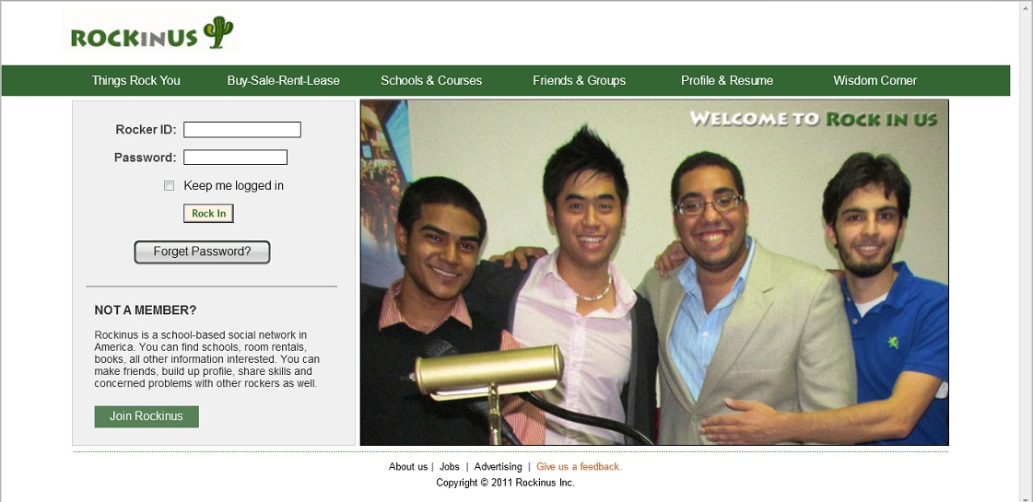
A Sample Cover of the Web

With Rockinus, users can: (In brief)
- After login, will see any updates that related to him. For example, a Computer Science student will be automatically updated with latest job interview notifications. Another example, a mechanic student will receive an update from other students who sell books that related to courses he selected. And so on. More, a guy who from Beijing China will receive updates from new rockers who from the same hometown joined the system, and so forth.
- Find schools, majors and courses. Before coming to U.S., can find out the most suitable school, majors that fit him, this will alleviate students school application concerns and torturing processes. They can also find appropriate courses for themselves. Students can check the comments/feedbacks and evaluation result on each course and professors from senior students. So they would be better notified before selecting courses.
- Find or release room rentals, books, etc.. For example, a new student who comes to U.S. for study are looking for a room or apartment, this would be useful. Another example is, a graduate students is going to graduate soon, he wanna sell his unneeded staff to other students, so to save cost using the web application.
- Make friends, build up groups by categories. For example, a new rocker named Joshave comes from New Delhi, India. He is able to find the rockers who come from the same hometown as him, and also study in the same school or same city. They could have a group. The groups are with different categories. Students can have outing group, group with same hobbies, like technical sharing groups, etc.
- Build up profile. Students can have profiles updates, and the resumes will be automatically generated. The system will provide several resume templates, students resumes will be created based on template selected. Companies can review students resume through the system. There will be a connection provider for the employers.
- Share skills and concerned problems with other rockers as well. The wisdom corner is used for this. For example, today an user has an idea, a technical issue or one spiritually thing in his mind, he can simply type it in wisdom corner so other rockers would see and comment. This would promote students communication and stimulate their inspiration for innovation as well.

In a word, the application is designed to help the students in U.S. or who gonna come to U.S. for study. It is targeted to make their lives much easier, by providing various in-time updates and most valuable customalized informations.

